About Page

The Irish consortium, Build Up Skills Ireland (BUSI), comprises five organisations; Limerick Institute of Technology (LIT) – as co-ordinators, Institute of Technology Blanchardstown (ITB) – leading the status quo report, Dublin Institute of Technology (DIT) – leading the consultation and roadmap development, Irish Congress of Trade Unions (ICTU) – for employee input, and Construction Industry Federation (CIF) – for industry input. A steering committee, comprised of the key national stakeholders in the training and energy sectors, was set up early in the project to guide the work of the consortium. National and regional workshops, interviews and surveys engaging relevant market actors will be undertaken in the consultation phase.
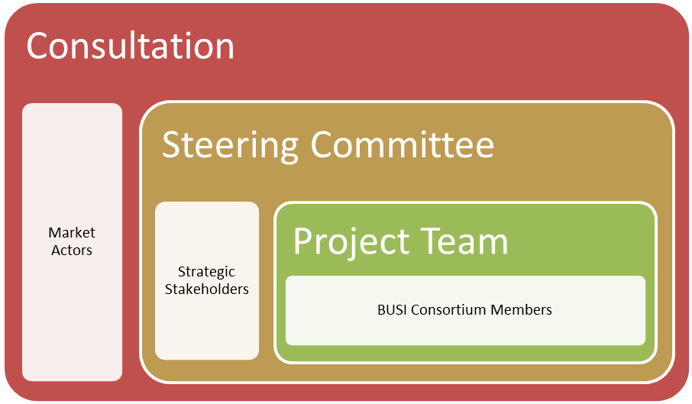
Figure 1.2: BUSI project structure

The BUSI project offers a timely opportunity to address the fundamental changes that are affecting the construction industry in Ireland while supporting the national commitment towards the 2020 energy policy targets. Building Regulations in Ireland have evolved dramatically in the last ten years and are fundamentally changing the approach to the construction of buildings as building designers strive to achieve the increasingly onerous energy performance standards that are being prescribed.
Until recently in Ireland, there has been no coordinated national response towards the continuous assessment of the skills needs of the building workforce in respect of energy utility. Separate initiatives, from agencies such as Sustainable Energy Authority of Ireland (SEAI), in response to the Article 14.3 of the RES directive, and FÁS (National Training and Employment Authority) provision of up-skilling courses for construction workers, have attempted to fill the gaps. It is a reasonable conclusion that the skills of practically every construction worker will need to evolve to realise the new targets for building energy performance, i.e. near zero carbon buildings as outlined in the European Performance of Buildings Directive (EPBD) recast (see 7.2 Identified Skills Needs later). The achievement of increasingly stringent air permeability standard for dwellings, for example, will require collective responsibility onsite from all involved in the construction process.

As a consequence of the boom in the construction industry from the mid-1990s to 2007, Ireland has been left with a surplus building stock. Consequently, it has been forecasted that the rate of new construction in the short to medium-term will be modest. As a result, it is acknowledged that the most significant potential for energy reduction resides with the retrofit of existing buildings. The construction workforce is the keystone to meeting this challenge, as it will be responsible for implementing the increasingly stringent detailing and specification that new designs and regulations will demand.

BUSI Activities Page
Status Quo Report
This report on the status quo endeavours to provide an objective analysis, both in qualitative and quantitative terms, of the training requirement needed to provide a building workforce capable of achieving 2020 targets. It also attempts to identify and estimate the real skills demand, both present and for the future. It draws the relationship between training and actual employment opportunities for the cohort by providing realistic projections based on trends and government supported jobs initiatives. This will be crucial to the engagement of participation on the proposed training schemes. The main objective of the report is to provide a comprehensive basis for discussion with all relevant national stakeholders and, therefore, endeavours to be as accurate and up to date as possible. The relevant government departments, national agencies, training and standards authorities have been engaged to provide access to data and information to this end, including:
- The Department of Communications, Energy & Natural Resources (DCENR) have provided updates on revisions to energy policy and actions for implementation.
- The Department of Environment, Community & Local Government (DECLG) have clarified the direction of changes to Building Regulations and how they anticipate this will affect the skills needed for onsite implementation.
- The Sustainable Energy Authority of Ireland (SEAI) have provided data and information on the penetration of renewable energies in buildings, initiatives and grant supported schemes for the public, commercial and residential sectors, including rates of energy efficient renovations.
- FÁS, the national training authority, have given access to the data held by their Skills and Labour Market Research Unit (SLMRU) to quantify employment and apprenticeship training in the construction sector and future projections. They have also provided data for the participation rates on the training programmes they provide relevant to energy efficiency and renewable energy in buildings.
- The Further Education and Training Awards Council (FETAC) and the Higher Education and Training Awards Council (HETAC) have supplied participation rates on the relevant programmes that they provide in this sector.
- The National Standards Authority of Ireland (NSAI) was consulted for clarification on their role in developing codes of practice in the field and their involvement in standards certification for related products and their installation.
The BUSI project coincides with a time of significant change in government policy in Ireland, national training structures and economic circumstances, all of which are relevant to training in construction. The underpinning themes of efficiency and sustainability, however, could not be more relevant or topical in the evolving national status quo.

